you will have noticed that each field on the selection screen contains the technical name of the field which we declared in our program.

Let's have a look how we can change that. Our program still needs to reference these types of fields, using the technical name. But the user always prefers to see the descriptive text. And to do this, we may use a special text element called selection text.

Now, as you know, every ABAP program is made up of its own sub-objects. Like text elements.

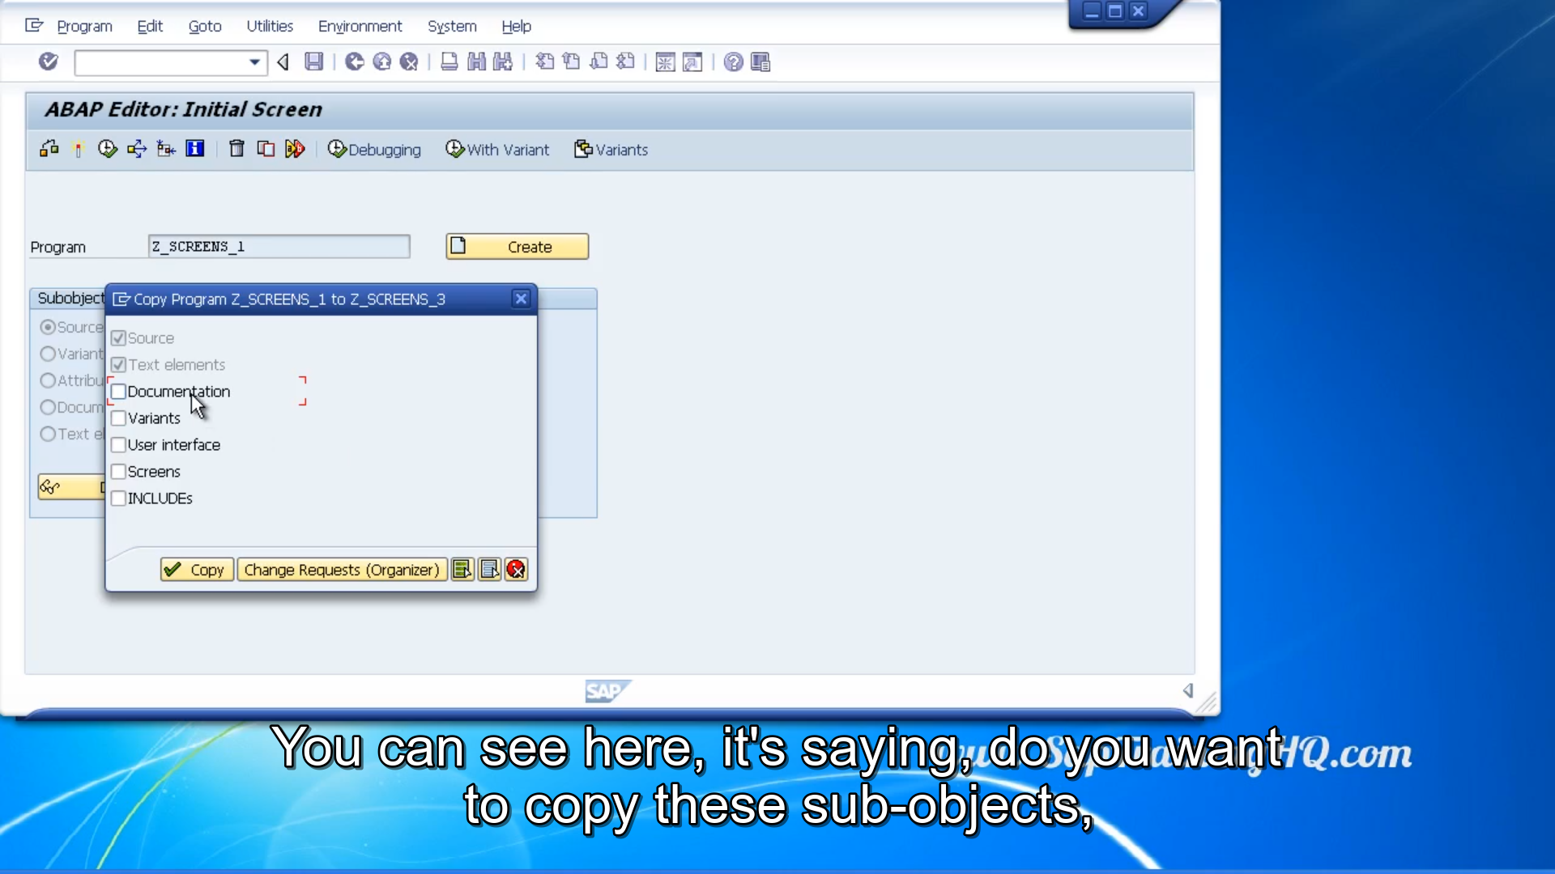

If we go back to the SE38 screen, you can see here, that when we create our program, or probably a better example is when we choose copy. Let's create one called screens three. You can see here, it's saying, do you want to copy these sub-objects, the documents, the variants, user interface, screens and includes?

Well notice we have got two types of objects. They are always copied no matter what you select on the screen. First one is obvious, it's the source code, but then the next one is the text elements. And your text elements that you create for your program, belong to your program, and that's why they have to be copied across.

Now when we create text elements, we create them in what are called text pools. And these text pools hold all the text elements of our program. Now every program that we create is language independent.

This means we create text elements for our program. That can be quickly and easily translated into other languages, without the need for changing our source code.

There are three kinds of text elements that we can use in our program. I've already hinted at one called selection text, but there are two others, text symbols and list headings.

Now tech symbols, these are text elements that we can create for our program, to give us some flexibility so we don't have to have code literals into our source code. We can use these text symbols instead.

List headings, when building reports, we create report headers. You know, the title and field names, or column headings and that type of thing.

By using list headings instead of hard coding, the headings into our program, we can ensure they get translated into any of the languages we need. And also, if the headings have to change later on, but we can just go in and change the list headings text elements, instead of changing the source code.

And the last one, selection text this is where you can display text elements on the screen, so that the user doesn't have to see the technical name, as we've seen in all of our examples up to now.

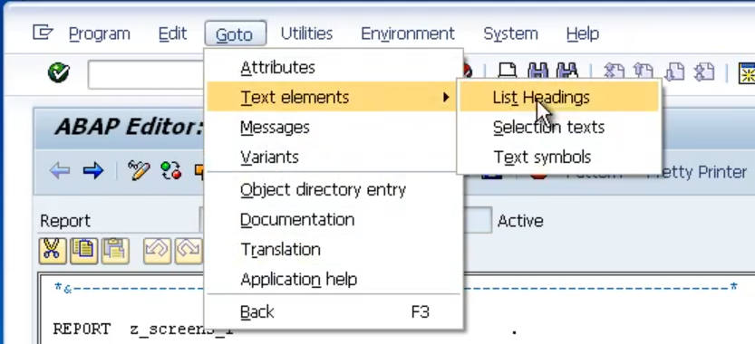

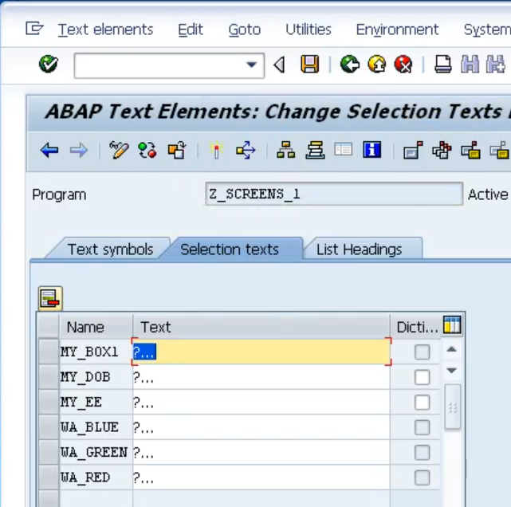

Go To menu, select text elements, and go to selection text from there. And as you can see, the other two, list headings and text symbols can also be navigated to from this menu. So, let's click on selection texts

Well, the fields that appear here on the left-hand side in the screen, they're the technical names for the fields we defined for our program.

Now, there's one thing to notice here. We have this third column, that refers to dictionary references. And what this is, it's recognizing that some of your fields refer to field setup in the about dictionary, and we're able to use this check box button. So, when I click this, and choose Save, notice how it brings the actual field name from the ABAP dictionary.

You know, the table we created earlier, and just populates it for us. This is one of the beauties of an SAP system. Everything works together. So, we don't have to declare our own text for these fields. Now you can of course choose not to use these dictionary objects, and just overwrite them yourself, put in any text you want.

you're limited to 30 characters in length for your text element. Now before these text elements can be used, just like programs and dictionary objects, we need to activate our text elements, which will automatically save them into the text pool for our programs to use.